**AWS CICD**

**Deploy Node Application**

**Open AWS Management Console**

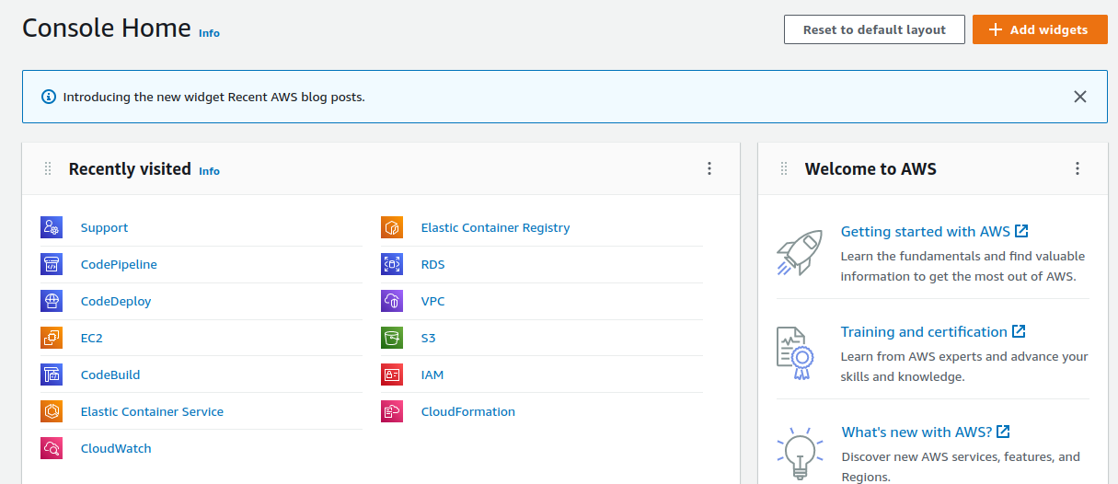

**Create 2 IAM Role For EC2 & Code Deploy**

**EC2**

Attached Policy

AdministratorAccess

AWSS3FullAccess

AWSCodeDeploy

**CodeDeploy**

Attached Policy

CodeDeploy

**Open IAM Service**

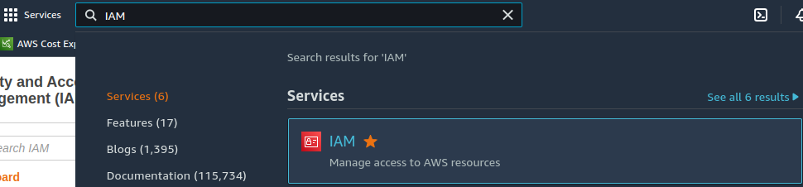

Open IAM Service

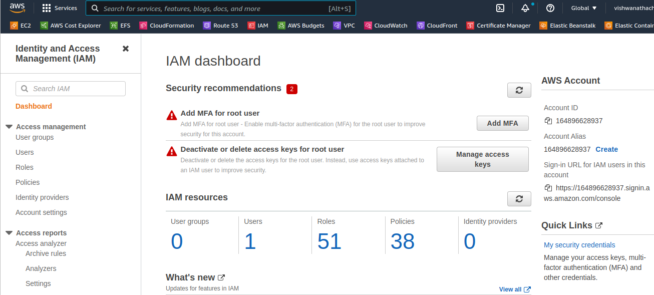

Open Role



Create Role

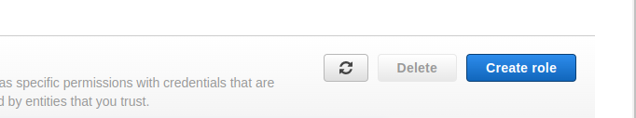

Select trusted entity

## **Trusted entity type**

AWS Service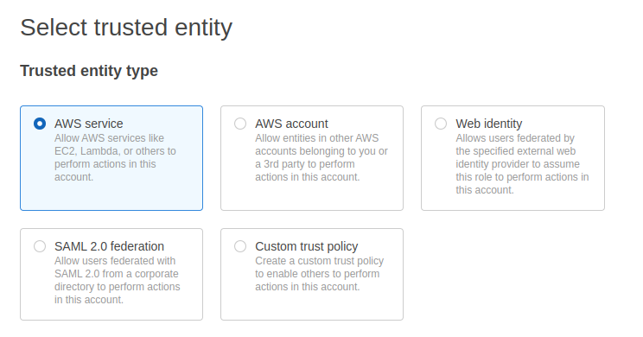

Choose Use Case

EC2

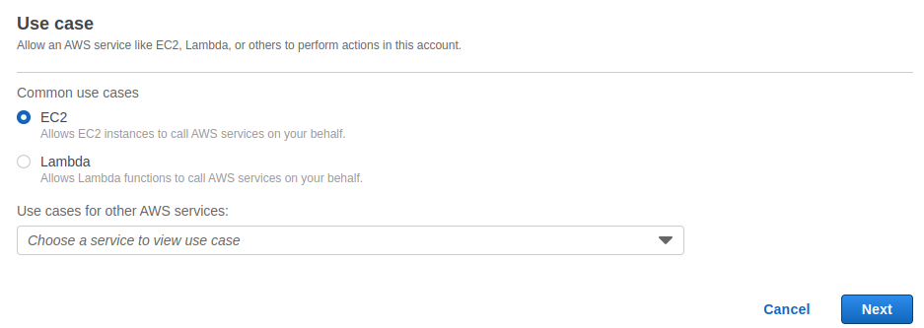

Search Policy You Need 2 Want here

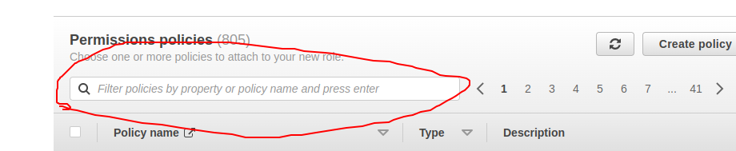

Role Name With Attached Policy

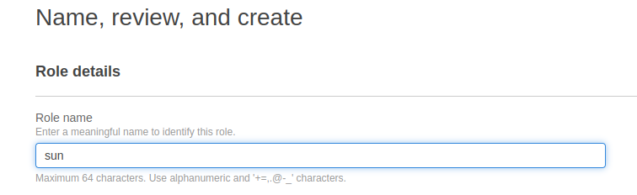

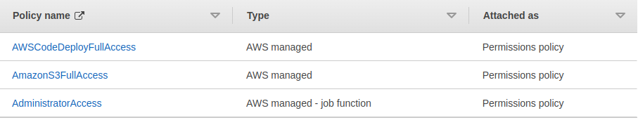

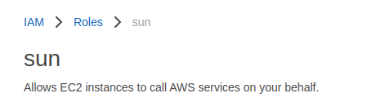

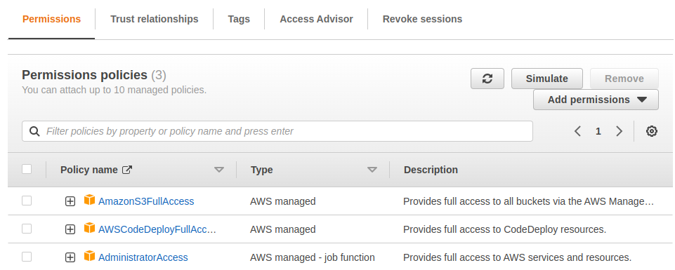

**Create Another Role**



Select trusted entity

## **Trusted entity type**



Search Code Deploy

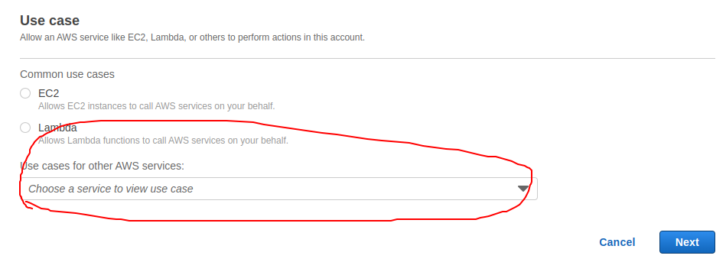

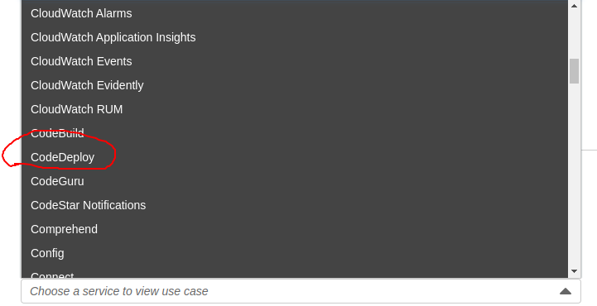

Choose CodeDeploy

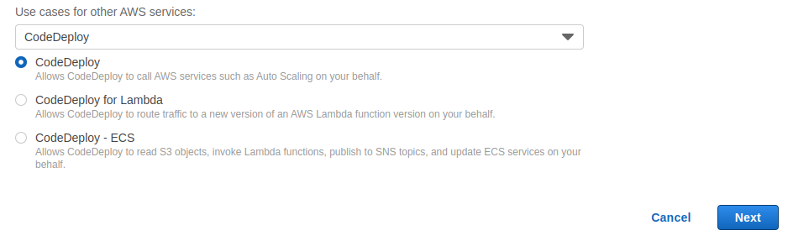

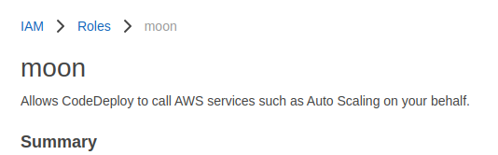

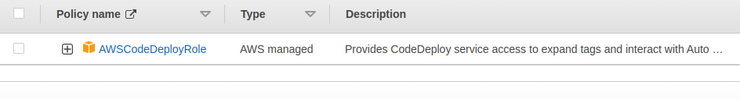

**Create EC2 instance With EC2 Role with Install CodeDeploy Agent with nodejs application with NPM**

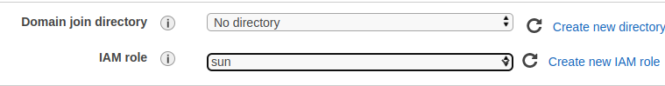

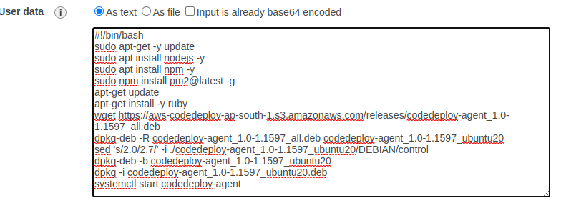

#!/bin/bash

apt-get update

apt-get install -y ruby

Wget https://aws-codedeploy-ap-south-1.s3.amazonaws.com/releases/codedeploy-agent_1.0-1.1597_all.deb

dpkg-deb -R codedeploy-agent_1.0-1.1597_all.deb codedeploy-agent_1.0-1.1597_ubuntu20

sed 's/2.0/2.7/' -i ./codedeploy-agent_1.0-1.1597_ubuntu20/DEBIAN/control

dpkg-deb -b codedeploy-agent_1.0-1.1597_ubuntu20

dpkg -i codedeploy-agent_1.0-1.1597_ubuntu20.deb

systemctl start codedeploy-agent

sudo apt-get -y update

sudo apt install nodejs -y

sudo apt install npm -y

sudo npm install pm2@latest -g

**ADD Tag**



Launch Instance!

Open Security Group port 3000

<https://github.com/vishwanathacharya/codedeploy-to-ec2-nodejs9.git>

**Go to CodeDeploy Service**

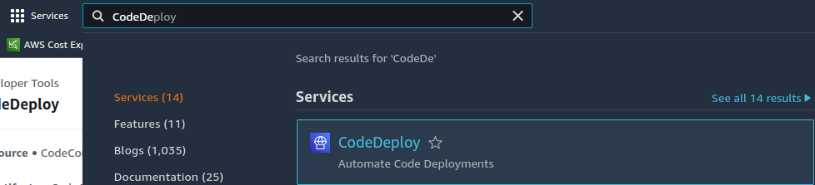

Open CodeDeploy Service

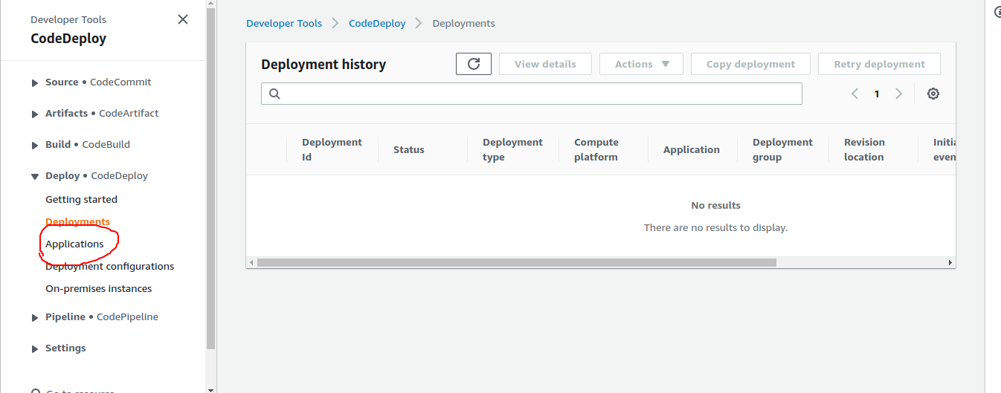

Open Applications



Create Application

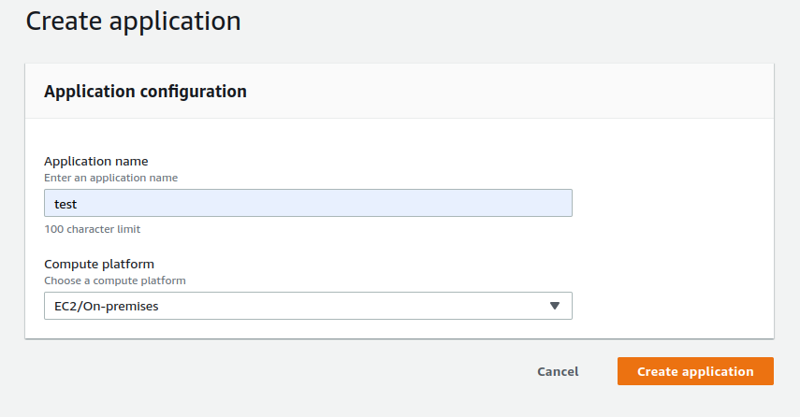

Create Deployment Group

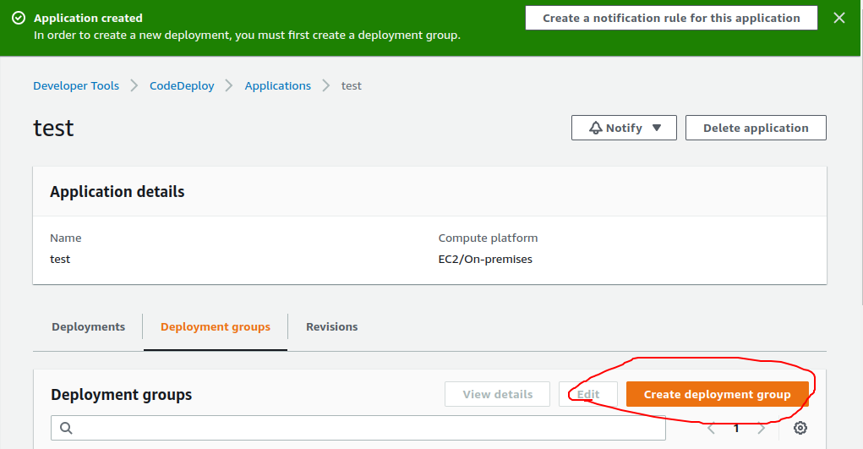

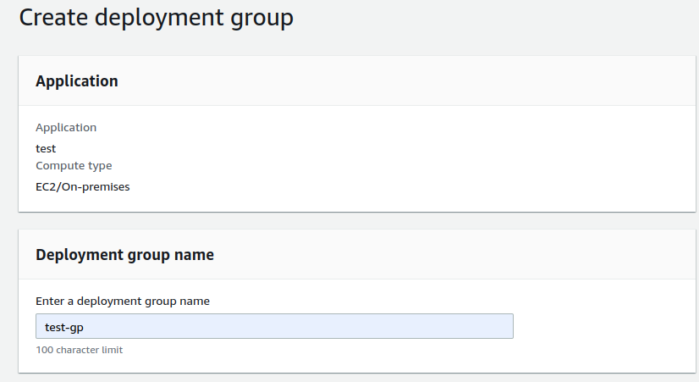

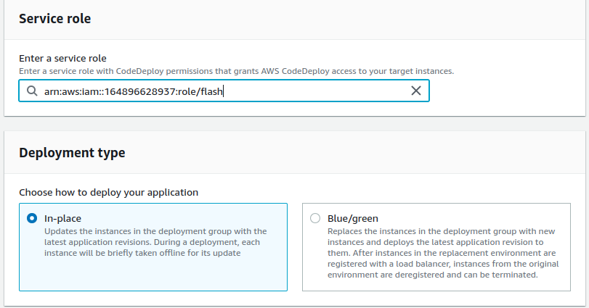

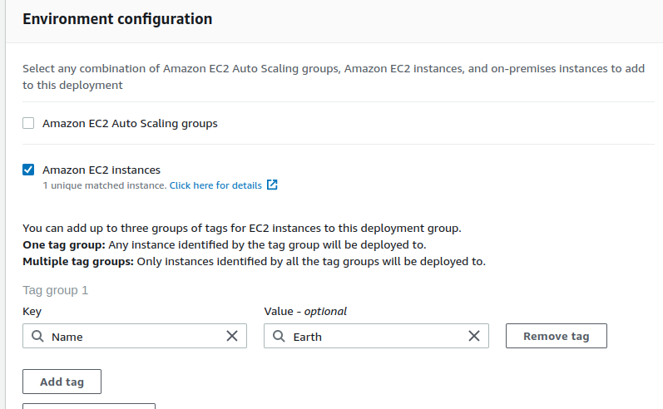

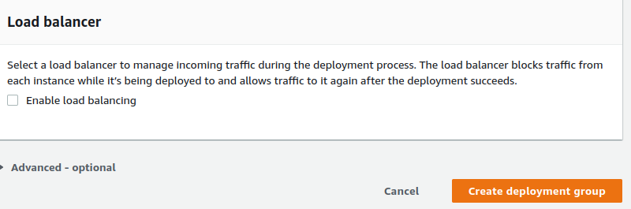

Than go to Pipeline

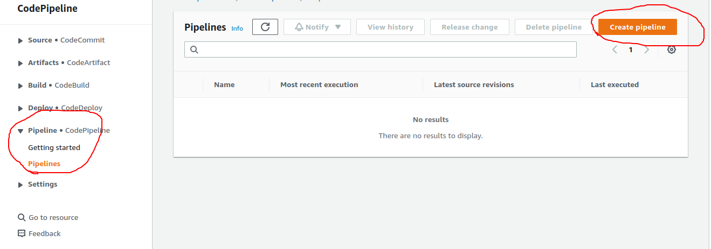

Create PipeLine

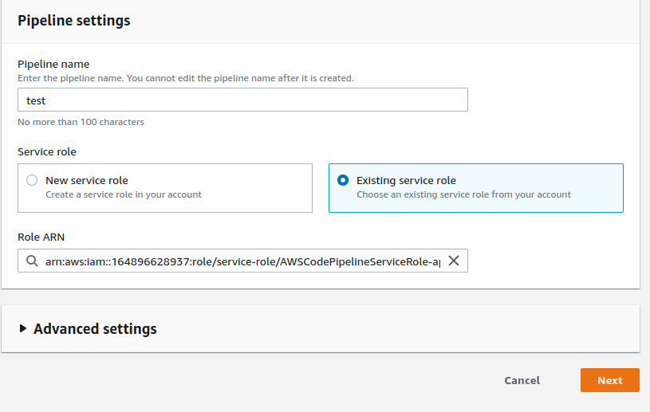

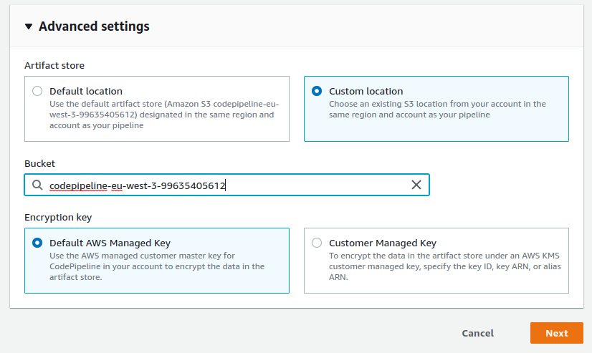

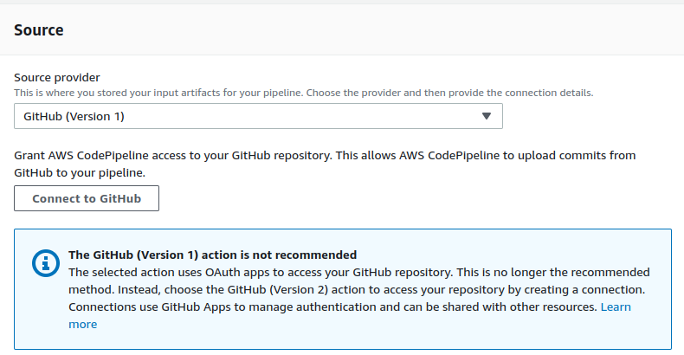

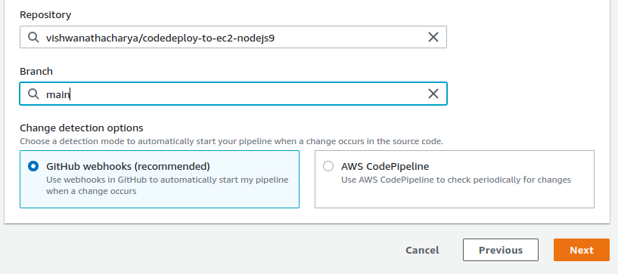

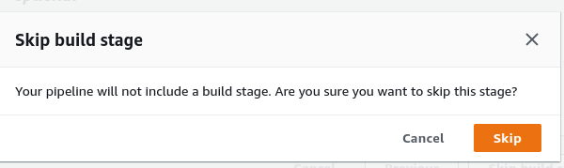

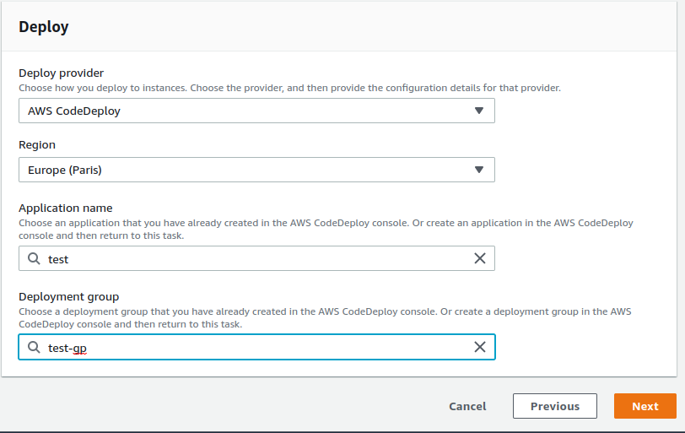

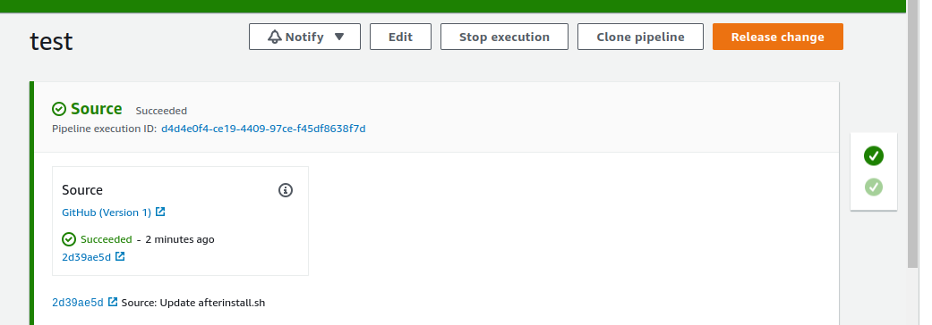

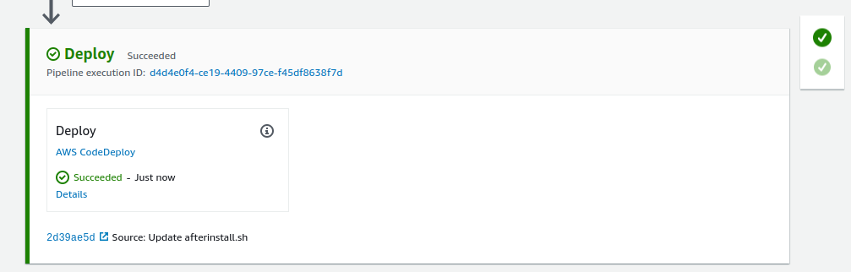

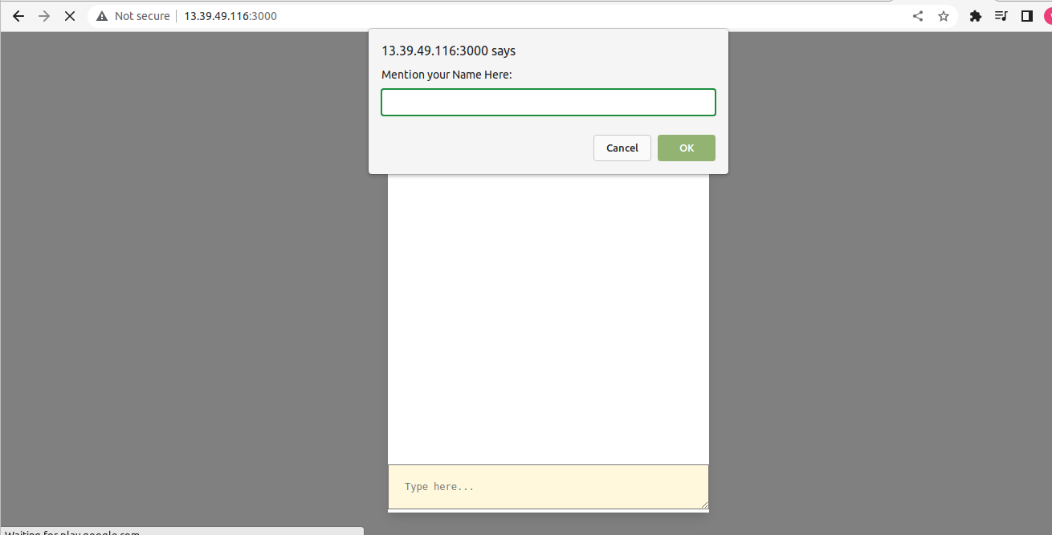

Use this for repo application